HOME AUTOMATION USING MOBILE

**Team no:** A1

**Project team members:**

U.Amith Sai (2451-12-733-044)

T.Sai Kiran (2451-12-733-028)

P.v.k. Rohith (2451-12-733-045)

**Project guide & Designation:**

G.Vijay kumar, Associate Professor,CSED.

2

**INDEX**

**S.No Name of Chapter Page No.**

1 Abstract 2

2 Problem statement 2

3 Hardware & Software Requirements 3

4 Basic system Architecture 3

5 Tools, Software, Relevant areas 4

6 References 5

**1. ABSTRACT:**

3

In Day to day life many of us will face the problem of controlling the home appliances when we are not in reach of them. Our project HOME AUTOMATION USING MOBILE will solve that problem. The basic components of the project are GSM SIM300 module, ARDUINO board, Arduino IDE. The main advantage of this project is user can control all the electronic devices in the house from any remote place in the world.GSM module has SIM card holder into which a valid SIM is placed. whenever user calls to that number the module gets activated and sends send commands to the Arduino board.The heart of the system arduino board will receive these signals and hence control the electronic appliances using relay switches. We need ATcommands to control the GSM module. Using arduino IDE we will develop a code and dump it in to the Arduino board. Based on these commands arduino board will control the appliances.

**2. PROBLEM STATEMENT**

4

**2.1 Existing System:**

**We can control home appliances only when we are present in the house.**

**2.1.1Disadvantages:**

  1.We cannot control it when we are out of the house.

2.Power consumption is high.

**2.2 Proposed System:**

**The system which we are developing gives us the flexbility by making us control the device from any remote place.**

**2.2.1 Advantages:**

**1. We can control it from anywhere in the world.**

**2. Power consumption is less.**

**3. HARDWARE & SOFTWARE REQUIREMENTS**

6

**3.1 Basic Hardware Requirements:**

**1.Arduino board**

**2.GSM sim 300 module**

**3.Connecting wires**

**4.Relay switch**

**3.2 Software Requirements:**

1.Coding Language : Arduino IDE

**4. SYSTEM DESIGN/BASIC SYSTEM ARCHITECTURE:**

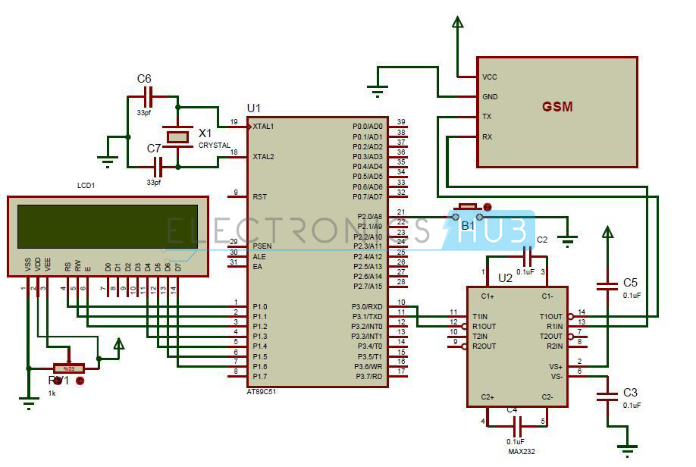

7

**5. TOOLS, SOFTWARE ,RELEVANT AREAS:**

The **Internet of Things** (**IoT**) is the network of physical objects or "things" [embedded](https://en.wikipedia.org/wiki/Embedded_system) with [electronics](https://en.wikipedia.org/wiki/Electronics), [software](https://en.wikipedia.org/wiki/Software), [sensors](https://en.wikipedia.org/wiki/Sensor), and [network connectivity](https://en.wikipedia.org/wiki/Internet_access), which enables these objects to collect and exchange data.[[1]](https://en.wikipedia.org/wiki/Internet_of_Things#cite_note-1) The Internet of Things allows objects to be sensed and controlled remotely across existing network infrastructure,[[2]](https://en.wikipedia.org/wiki/Internet_of_Things#cite_note-2) creating opportunities for more direct integration between the physical world and computer-based systems, and resulting in improved efficiency, accuracy and economic benefit.[[3]](https://en.wikipedia.org/wiki/Internet_of_Things#cite_note-3)[[4]](https://en.wikipedia.org/wiki/Internet_of_Things#cite_note-4)[[5]](https://en.wikipedia.org/wiki/Internet_of_Things#cite_note-5)[[6]](https://en.wikipedia.org/wiki/Internet_of_Things#cite_note-6)[[7]](https://en.wikipedia.org/wiki/Internet_of_Things#cite_note-7)[[8]](https://en.wikipedia.org/wiki/Internet_of_Things#cite_note-8) Each thing is uniquely identifiable through its embedded computing system but is able to interoperate within the existing [Internet](https://en.wikipedia.org/wiki/Internet) infrastructure. Experts estimate that the IoT will consist of almost 50 billion objects by 2020.[[9]](https://en.wikipedia.org/wiki/Internet_of_Things#cite_note-9)

[British](https://en.wikipedia.org/wiki/United_Kingdom) entrepreneur [Kevin Ashton](https://en.wikipedia.org/wiki/Kevin_Ashton) first coined the term in 1999 while working at the Auto-ID Labs (originally called Auto-ID centers - referring to a global network of RFID connected objects).[[10]](https://en.wikipedia.org/wiki/Internet_of_Things#cite_note-10) Typically, IoT is expected to offer advanced connectivity of devices, systems, and services that goes beyond [machine-to-machine communications (M2M)](https://en.wikipedia.org/wiki/Machine_to_machine)and covers a variety of protocols, domains, and applications.[[11]](https://en.wikipedia.org/wiki/Internet_of_Things#cite_note-M2M-IoT-11) The interconnection of these embedded devices (including [smart objects](https://en.wikipedia.org/wiki/Smart_objects)), is expected to usher in automation in nearly all fields, while also enabling advanced applications like a [Smart Grid](https://en.wikipedia.org/wiki/Smart_grid),[[12]](https://en.wikipedia.org/wiki/Internet_of_Things#cite_note-Smart-IoT-12) and expanding to the areas such as [smart cities](https://en.wikipedia.org/wiki/Smart_city).[[13]](https://en.wikipedia.org/wiki/Internet_of_Things#cite_note-13)[[14]](https://en.wikipedia.org/wiki/Internet_of_Things#cite_note-14)

"Things," in the IoT sense, can refer to a wide variety of devices such as heart monitoring implants, [biochip](https://en.wikipedia.org/wiki/Biochip) transponders on farm animals, electric clams in coastal waters,[[15]](https://en.wikipedia.org/wiki/Internet_of_Things#cite_note-MolluSCAN_eye-15)automobiles with built-in sensors, or field operation devices that assist firefighters in [search and rescue](https://en.wikipedia.org/wiki/Search_and_rescue) operations.[[16]](https://en.wikipedia.org/wiki/Internet_of_Things#cite_note-Definition-IoT-16) These devices collect useful data with the help of various existing technologies and then autonomously flow the data between other devices.[[17]](https://en.wikipedia.org/wiki/Internet_of_Things#cite_note-IoT_journal-17)[[18]](https://en.wikipedia.org/wiki/Internet_of_Things#cite_note-18) Current market examples include [smart thermostat](https://en.wikipedia.org/wiki/Smart_thermostat) systems and washer/dryers that use Wi-Fi for remote monitoring.

Besides the plethora of new application areas for Internet connected automation to expand into, IoT is also expected to generate large amounts of data from diverse locations that is aggregated very quickly, thereby increasing the need to better index, store and process such data.

**6. REFERENCES:**

**1.** [**http://www.electronicshub.org/**](http://www.electronicshub.org/)

**2.** [**https://learn.sparkfun.com/tutorials/what-is-an-arduino**](https://learn.sparkfun.com/tutorials/what-is-an-arduino)

**3.** [**http://www.engineersgarage.com/articles/gsm-gprs-modules**](http://www.engineersgarage.com/articles/gsm-gprs-modules)